Load-Balancing in File Systems
Nadine Amsel
Storage Systems Research Center
University of California, Santa Cruz

Abstract
Overload in file systems is determined by the number of queries an OSD receives in a minute. We determined magnitude of OSD overload by mapping query terms to OSDs. Results showed that index query workloads cannot be effectively addressed by increasing the number of OSDs. Therefore load-balancing mechanisms need to adapt on a minute-by-minute basis.

Introduction
Ceph is a petabyte-scale, distributed storage system developed and maintained at UCSC [Weil06a]. Ceph uses a hash function for data placement -- an essential technique for its scalability. However the hash function does not perform well under skewed workloads. Large scale storage systems rely on search functionality that requires indices. Indices come in many forms -- for the purpose of this paper we assume inverted files that consist of a vocabulary of terms that are each mapped to a postings list, a list of references to documents that contain that term [Zobel06].
Index access distributions are highly skewed and query access distributions change frequently. The focus of my research was finding the extent of overload and the time scale of overload periods in a distributed storage system. We define overload as when the number of arriving queries exceeds the capacity to respond to these queries. There are many techniques for load balancing and we need to find out which techniques are appropriate. There tends to be a trade-off between how quickly a balancing mechanism can adapt and how much overhead the mechanism itself causes.
There are no query traces of very large file systems but there are query traces of Web search engines. These conceivably approximate large file system query traces. We used traces from 500,000 AOL users over 3 months to determine overload patterns.
Results showed that even large numbers of nodes will not completely prevent overload of individual nodes. This means that workload profile changes within minutes because 99% of all overload periods are no longer than an hour.

Related Work
Ceph is a distributed file system that provides excellent performance, reliability, and scalability [Weil06a]. Ceph uses a pseudo-random data distribution function called CRUSH to efficiently map data to clusters of object storage devices (OSDs) [Weil06b]. There has been some previous work done in load balancing to ensure that storage devices do not get too overload. D-SPTF, Distributed Shortest-Positioning Time First, is a “request distribution protocol” for storage systems [Lumb04]. One of its many features is load balancing, which is done by using high-speed communication to coordinate decisions among the storage bricks in a storage system. D-SPTF uses replicas of these storage bricks to help with load balancing. All read and write requests are sent to each brick replica but only one services the request. During high activity, all bricks with relevant data are involved in processing requests. The Shortest-Positioning-Time-First (SPTF) algorithm allows the bricks to decide which brick should contribute to which data requests.

Scalability in Ceph
Using a hash function is important for scalability. This keeps the description of the entire state of the cluster limited to a few kilobytes so information can be quickly communicated throughout the storage cluster and storage clients. But a single overloaded OSD can slow down the whole system because files are striped across objects, each stored on different OSDs. Reading or writing a file is only as fast as the slowest OSD involved. Managing increasing amounts of data requires searching. Searching requires indexing. The access profile to indices is not uniform but highly skewed, often following a Zipf distribution. Query access distributions depend on what people are currently interested in which tends to change continually. To address indexing workloads, we need to find scalable load-balancing mechanisms that are well-suited to the magnitude of load-imbalance and the time scale of load balance changes. Mechanisms that can quickly adapt also usually incur a larger overhead as mechanisms that don't adapt or adapt less quickly. My work focused on finding the extent of overload and the time scale of overload periods in a distributed storage system in order to determine the extent to which load-balancing is necessary.

Approach
We took query traces from AOL searches to determine the magnitude of OSD overload. The query traces of Web search engines conceivably approximate large file system query traces. The AOL traces contained an anonymous id, the (non-filtered) search query, query time, item rank, and click URL [Pass06]. We stored and reordered the data using a Postgres database, Python scripts with Postgres interface module. To make the tests simpler, we assumed a distributed storage system: the posting list of a term is stored in at most one OSD, i.e. terms are hashed over OSDs. We converted AOL queries into single-term queries, counted how many of those queries each OSD receives per trace time minute, and determined how many OSDs of a given cluster were overloaded at any particular minute. We also determined the distribution of overload period lengths. We analyzed query traces using different numbers of OSDs and overload thresholds: 128, 1K, and 64K numbers of nodes and 10, 30, and 50 queries/minute threshold values.

Results
The results showed that overload occurs even if the queries are distributed over a large number of OSDs. Overload occurs all the time and just one overloaded OSD can slow down the whole system. The mean and median numbers of OSDs overloaded are shown in the graph and table below:

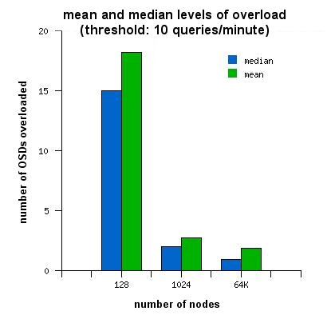

 | 128 nodes | 1K nodes | 64K nodes
Median | 18 | 3 | 2
Mean | 15 | 2 | 1
Graph, Table 1: Mean and median levels of overload. Increasing the number of nodes does not completely prevent overload.

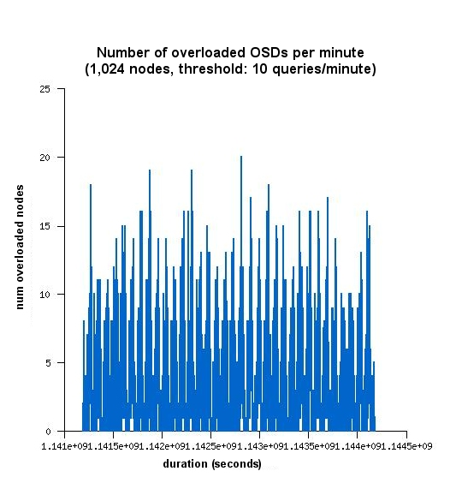
Graph 2: 1,024 OSDs; threshold of 10 queries/minute. There is no specific pattern of overload and overload occurs all the time.

These figures show that increasing the number of OSDs is not a solution.

Results also show that most OSDs do not stay overloaded for more than a few minutes. The median overload lengths for 128 and 1K nodes are ~4 and ~2 minutes, respectively. The results also indicate that in 99% of all cases the overload period lasts no longer than an hour.

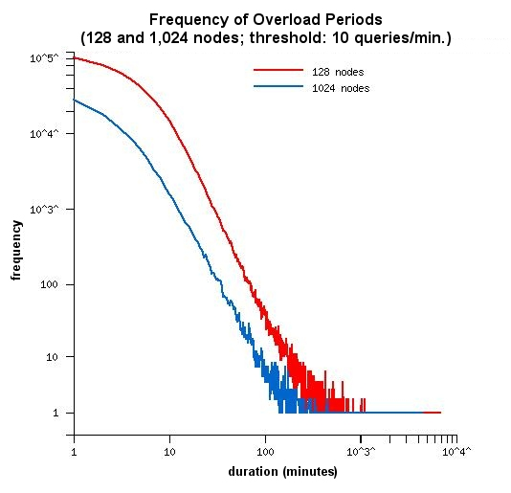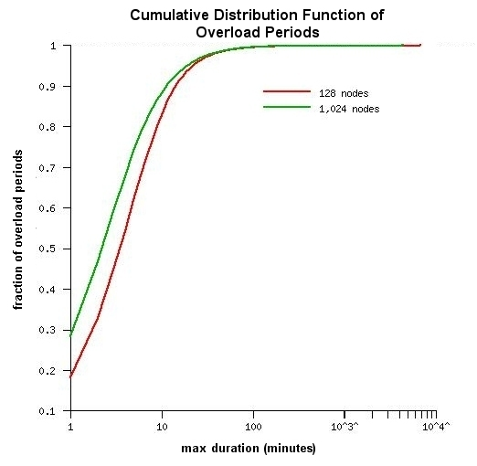

Graph 3, 4: The overload times usually last only a few minutes. Most overload periods last less than an hour, so load balancing mechanisms must adapt quickly to keep up with the workload.

Index query workloads cannot be effectively addressed by increasing the number of OSDs. Therefore load-balancing mechanisms need to adapt on a minute-by-minute basis. Any mechanism that takes longer than an hour to adapt will not be able to keep up with 99% of the workload changes.

Conclusion and Future Work
Query workloads cannot be effectively addressed by increasing the number of OSDs. Therefore load-balancing mechanisms need to adapt on a minute-by-minute basis. Any mechanism that takes longer than an hour to adapt will not be able to keep up with 99% of the workload changes. Future work involves changing the evaluation program to account for one-minute dips in overload. This means the overload period would only be "complete" if there was no overload for at least two minutes, instead of one. This could show that the majority of overload periods are actually much longer.

Acknowledgements
The faculty members of the Storage Systems Research Center were most helpful in the research process. This work was supported by UCSC, SURF-IT, and NSF grant #CCF-0552699. Much thanks also goes to Richard Hughey, director of the SURF-IT program at UCSC.

References
G. Pass, A. Chowdhury, C. Torgeson, "A Picture of Search" The First
International Conference on Scalable Information Systems, Hong Kong, June,
2006.
Weil, Sage, Brandt, Scott A., Miller, Ethan L., Maltzahn, Carlos, Ceph: A Scalable, High-Performance Distributed File System, Proceedings of the 7th Conference on Operating Systems Design and Implementation (OSDI '06), November 2006.
Weil, Sage, Brandt, Scott A., Miller, Ethan L., Maltzahn, Carlos, CRUSH: Controlled, Scalable, Decentralized Placement of Replicated Data, Proceedings of SC '06, November 2006.
Zobel, J., Moffatt, A. (2006). Inverted Files for Text Search Engine, ACM Computing Surveys, 38(2).

