This summer Victor De La Rosa had the opportunity of working in the Autonomous Systems Laboratory at the University of California, Santa Cruz campus. He worked with David Ilstrum, a graduate student, under the guidance of professor Gabriel Elkaim. This program gave him insight as to how graduate student life is like and the challenges of independent research. He and David worked, as a team, on designing an inexpensive laser range finding system.
During the research experience, he help in designing circuitry, testing the properties of our equipment, as well as many other engineering tasks. He learned that patience is an important virtue when involved in research. As an undergraduate, you learn how to apply proven concepts, but as a graduate student you have theories that haven’t been proven yet, so the results you expect may not be as easy to achieve, as you believe. All in all, he thought it was a rewarding experience and would recommend it to other students.

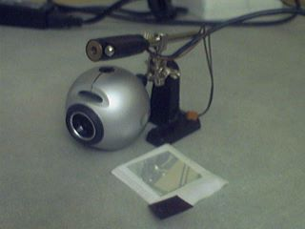This is the equipment used for the laser range finding system. Pictured above is the: laser pointer, web cam, one-way transparent mirror, and red filter.

