FPGA OVERCLOCKING

A PLATFORM TO MODEL IC VARIABILITY
Miguel A Salcedo
Professors: Jose Renau & Francisco ‘Javi’ Mesa-Martinez
Department of Computer Science
University of California, Santa Cruz

TABLE OF CONTENTS:

1. Overview……………..……………………………………………………………………………………….3

2. Introduction………………………………………………………………………………………………….3

3. Materials…………………………….…………………………………………………………………………3

4. Approach…………………..………………………………………………………………………………….4

5. Prototype………………………………………………………………………………………………………4

6. Results.………………………………………………………………………………………………………..5

Appendices ………………………………………………………………………………………………………7

Acknowledgements……………………………………………………….…………………………………8

References..……………………………………………………..........................................8

1 OVERVIEW
Variability is one of the main limiter in the modern chip fabrication, as the integrated circuits keeps getting smaller variability increases exponentially. Variability is the name given to numerous parameters that affect the electric current at the transistor level. Some of the parameters which cause variability during the fabrication process are: Hot electron, electron migration, lithography nodes and transistor defects. Parameters such as hot electron and electron migration are due to the huge increase of the electric field inside the transistor. As transistors size reduces going beyond the 65 nm scale, the electric field starts increasing exponentially within transistors, making more difficult to handle some of these parameters.

2 INTRODUCTION
The purpose of this paper is to present a possible prototype to model IC variability. As Moore’s law continuous to be factual in our time, variability is becoming the main concern for IC designers. It is important to start developing new techniques to increase the processing ability that can be obtained from the existing technology. The platform to model IC variability is intended to map the regions in IC chips according to their variability grade. By mapping different regions of variability, it would allow in future research to create or modify architecture for a better performance.

In order to detect and map variability in a chip, a model program was designed in verilog and downloaded in a FPGA virtex-II PRO. As it is known, variability is the time delay that occurs at the transistor level when a computation is taking place at high frequencies. The time delay (current delay) in a computation causes the program implemented in the IC to produce erroneous data. By duplicating the model throughout the chip and running it at different frequencies, it will allow us to determine the locations where the errors occur and then create a variability map report.

3 MATERIALS

- FPGA VIRTEX II- PRO
- Xilinx ISE 9.2
- ModelSim - verilog simulator
- Clock Generator
- Frequency Analyzer

4 APPROACH
In order to create a platform to model IC variability, a 6-bit multiplier was designed and replicated throughout the FPGA. Each multiplier takes 15 data inputs which are stored in a ROM file and the output produced is compared with expected output data. All multipliers shared the same clock; the function generator is used to generate the clocking frequencies of all multipliers. By mapping all the failures and frequencies that occurs while the test is taking place, it will allow us to generate a variability map for the target chip. The region where the first set of multipliers fail at increasing frequency will indicate a high level of variability at that specific region. It is expected that the number of errors start propagating around the first set of failures (at the begging of test). In order to make a good estimate of variability regions in FPGA, there were used a great amount of multipliers to cover most of the region of the chip.

5 PROTOTYPE

- Create multiplier (6bit)
- Scan-chain method to test & collect data from multipliers
- Duplication - Replicate multiplier throughout the chip (Xilinx II PRO XC2VP30) using a common clock
- Analyze & map data

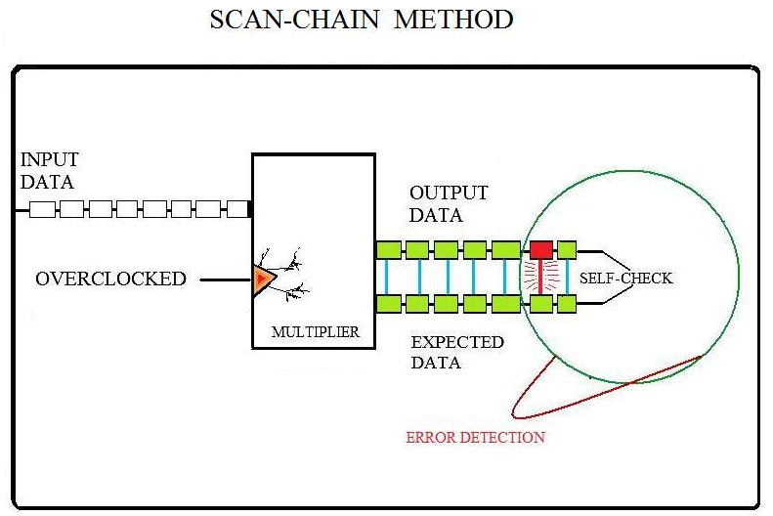
2

Figure 1

Scan-chain is a method used to chain all multipliers and scan for errors that might occur during the multiplication. All data results are stored in register which can be read to map the different areas of variability in the FPGA chip. Each multiplier is getting 15 data values, which are store in a ROM file.

3 4

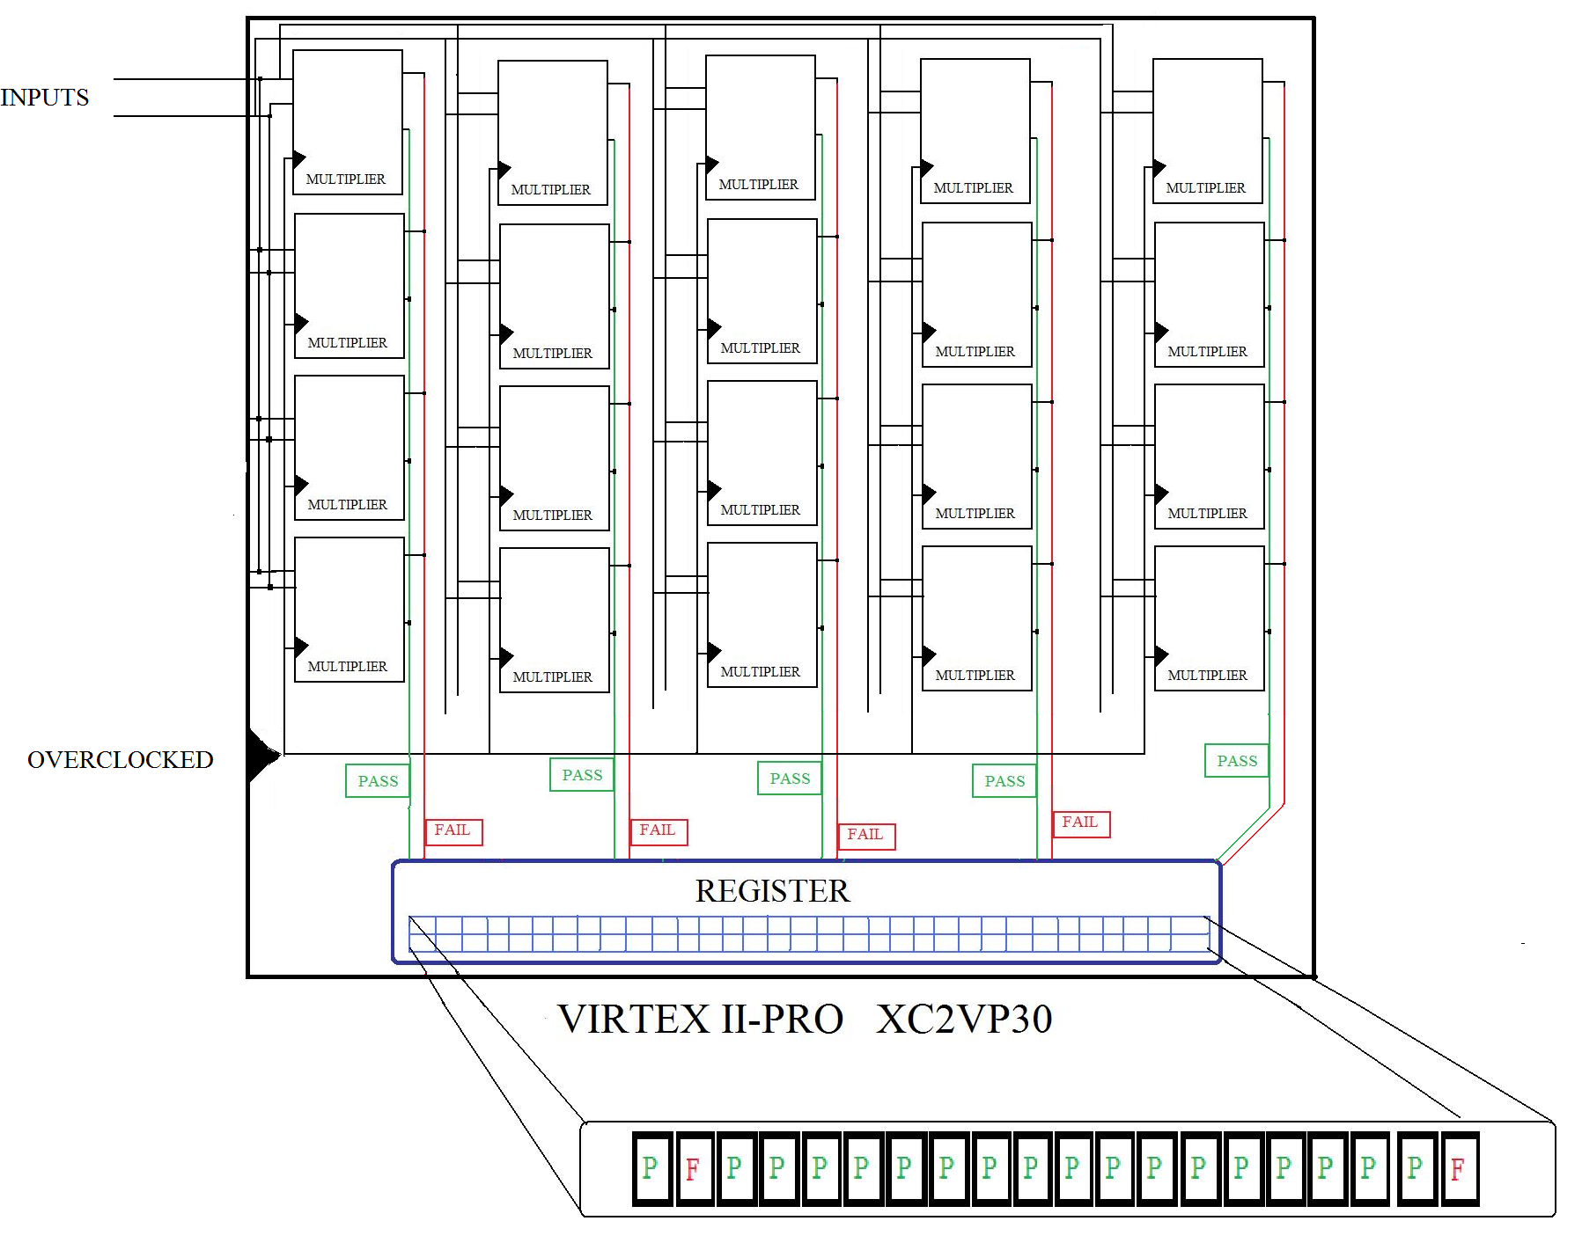
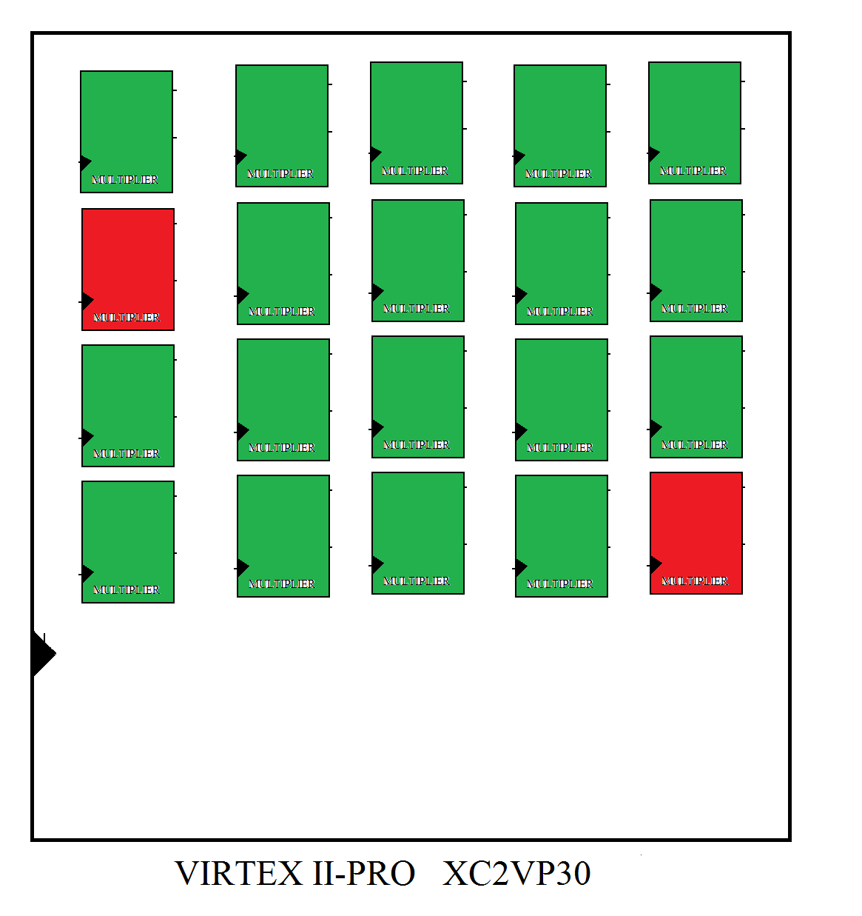

Figure 2

A duplication of 25 multipliers (number of LUTS or slices) is implemented; the idea is to cover most of the FPGA chip in order to be able to trace all different region of variability. The frequency generator is used to generate the system clock for all the multipliers. The data result is sent to a register which is analyzed to be able to map the errors that occurred during the test.

6 RESULTS:
Figure 3 represents the 25 multipliers distributed throughout the virtex II PRO chip. The multipliers occupied 475 slices out of 2,816; which means that the chip can store up to 146 multipliers. Slices are the term used to represent flip-flops and latches presented.

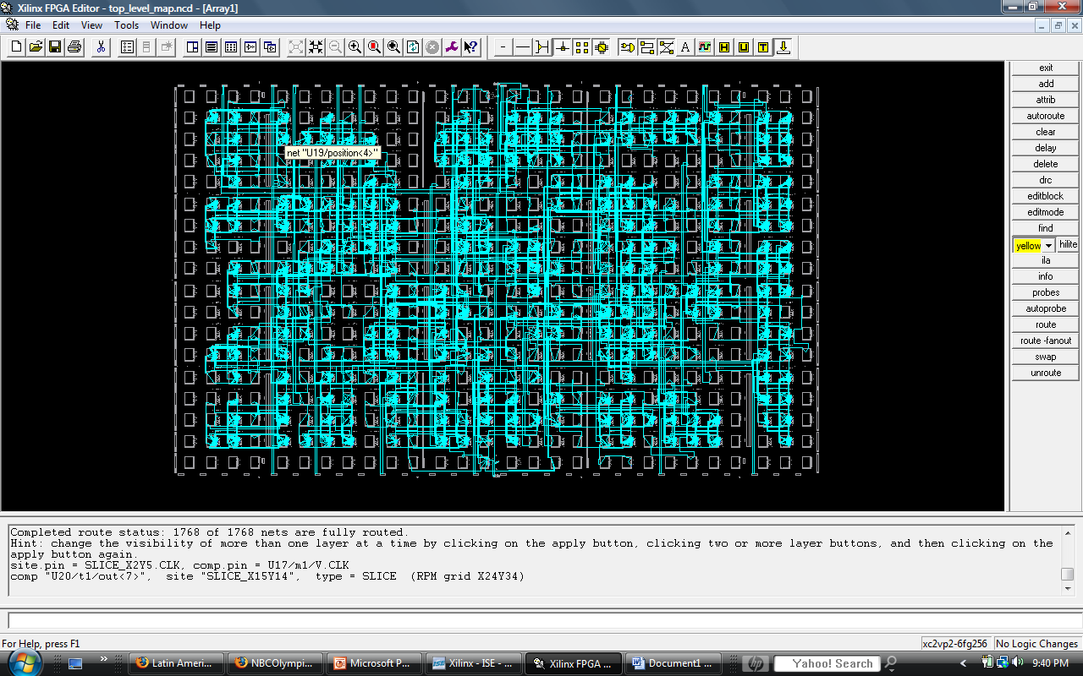

Figure 3
Figure 4 represents the data taken after several runs. It can be notice that the multipliers start failing at 115MHz and increases rapidly. The final breaking frequency for all the multiplier occurs at 140MHz.

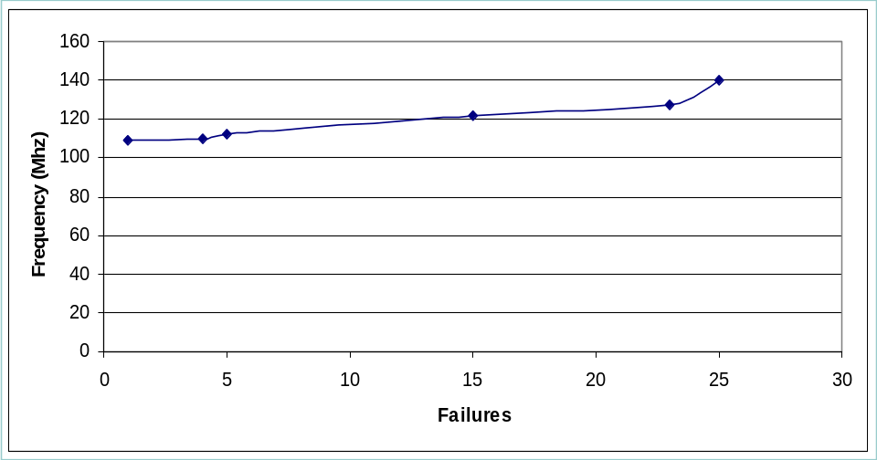

Figure 4

According the manufacturer specification the board operates at a maximum of 100 MHz frequency. But by looking a figure 5 and 6, we can recognize the different working frequencies. Figure 5 represent 15 multiplier failures between 115MHz and 125MHz, which corresponds to the lower bottom of the chip. Figure 6 illustrates 10 failures occurring at the top of the chip. From these images we can determine that the left lower section contains most of the variability in the target chip. It is also found that maximum working frequency occurs at 130 MHz in the upper section of the virtex II-PRO chip.
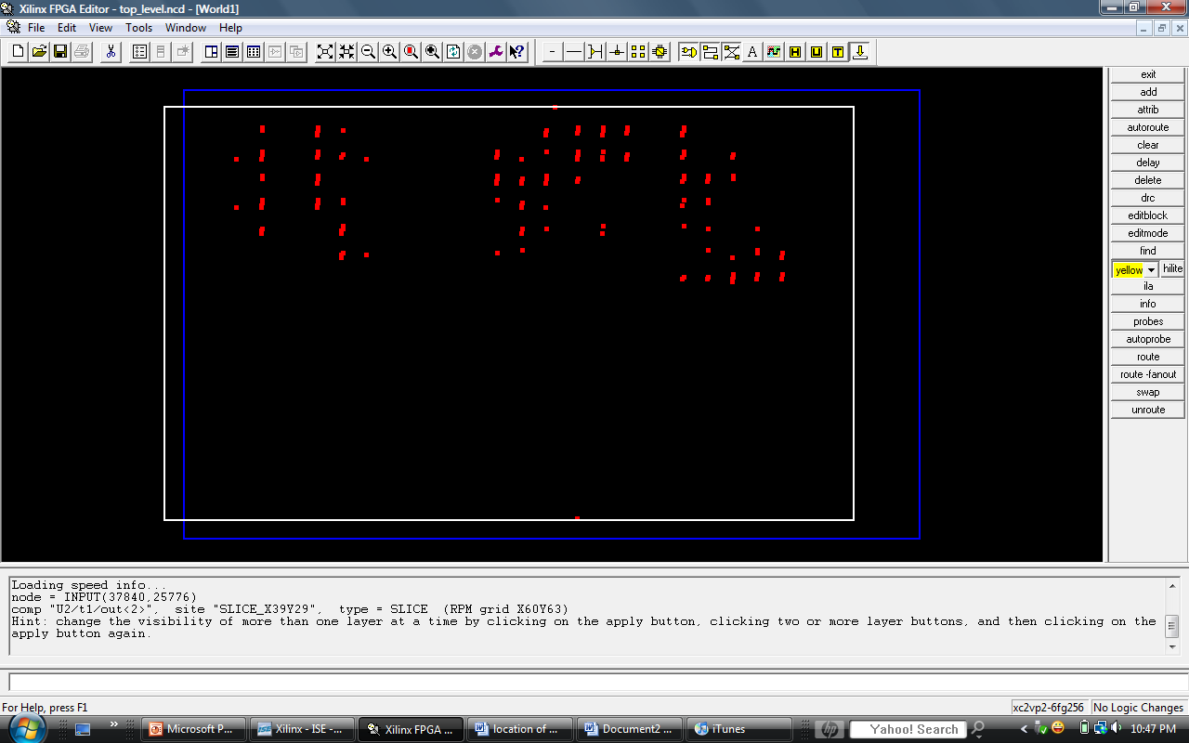
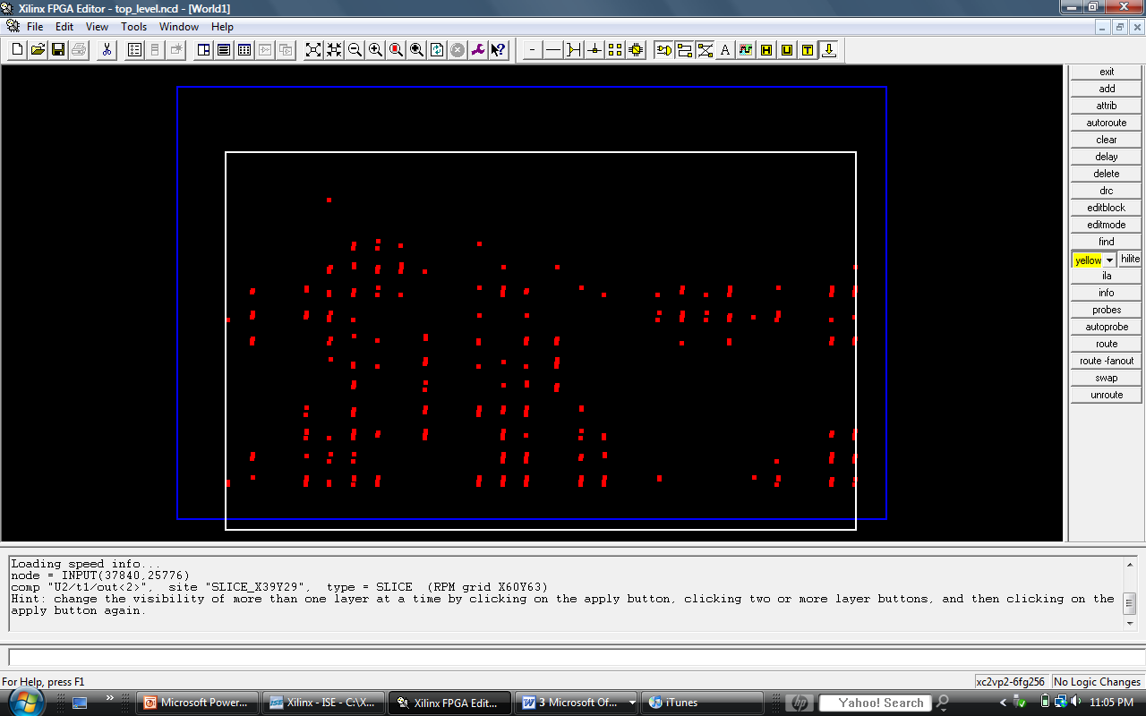

Figure 6
Upper left group form 4 failures at 130MHz
Upper right group form 6 failures at 140MHz
Figure 5
Red dots represent 15 multipliers failures in the frequency range of 115-125MHz

Note: appendices A, B and C represent the sequence of failures of the multipliers till it reaches the breaking frequency of 14OMHz

APPENDICES

APPENDIX A
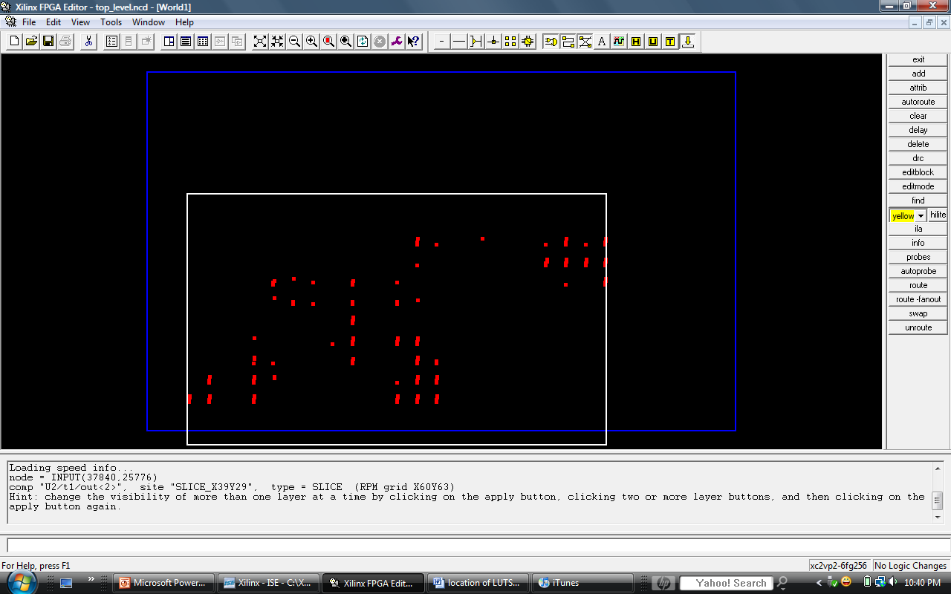

The preceding image represents 7 Failures (multipliers failed) between 115 MHz – 117 MHz

APPENDIX B
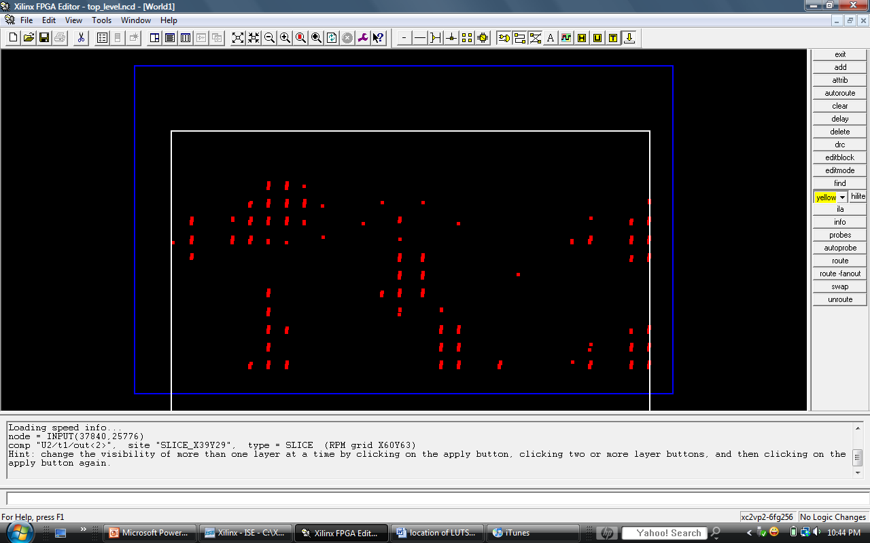

The preceding image represents 8 more failures between 117 MHz – 125 MHz

APPENDIX C

4 Failures at 130 MHz 6 failures at 14O MHz
ACKNOWLEDGEMENTS
I would like to thank the NSF and SURF-IT program for the research opportunity and Professor Jose Renau and Javi Martinez for their support during my stay at UCSC.

REFERENCES
- http://www.research.ibm.com/journal/rd/504/bernstein.html
2 Diagnose Compound Scan Chain and System Logic Defects, by: Yu Huang, Wu-Tung Cheng.

